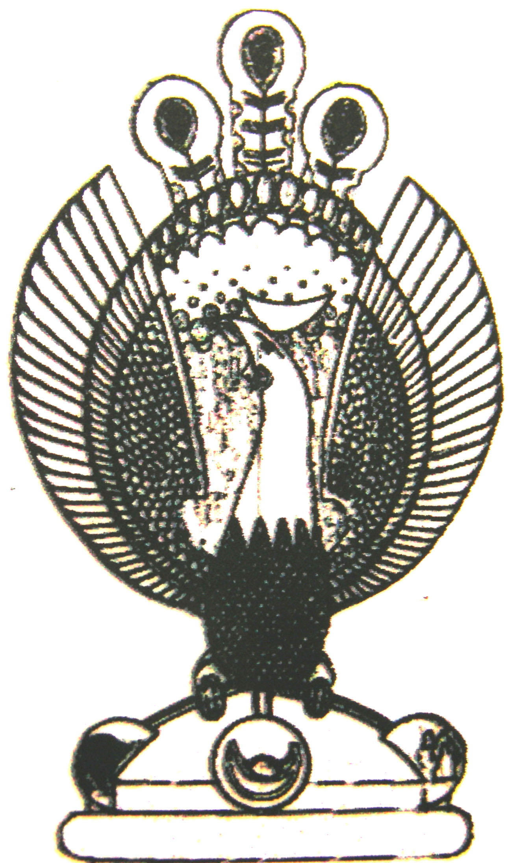

THE HERITAGE

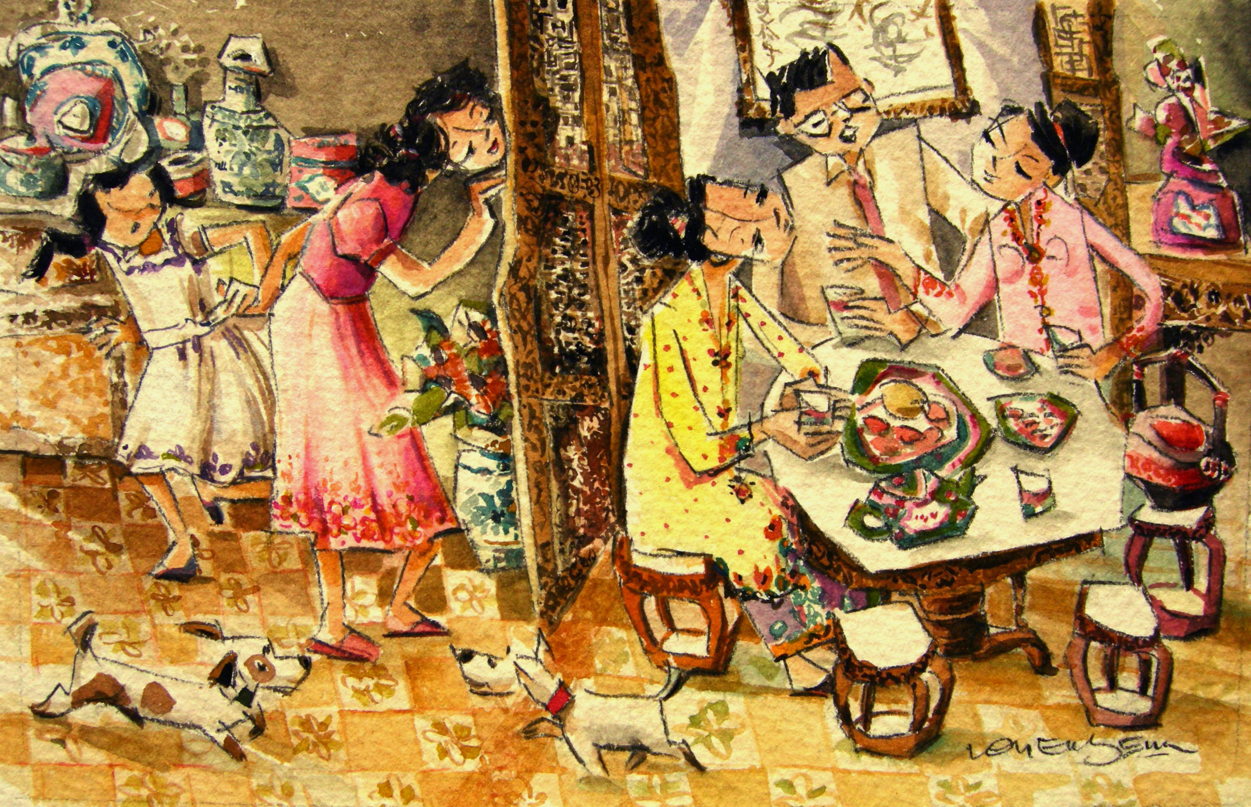

Matchmaking
Matchmaking was the norm, with the bride and groom not meeting each other till the wedding day, up till half a century ago. Most peranakan weddings were matrilocal, so the husband lived with the wife’s family after the marriage.

